## Task 01: CREATE Example of Select Parallel execution

CREATE TABLE test_parallel AS

SELECT

LNG_ID ,

LNG_3C_CODE ,

LNG_2B_CODE ,

LNG_SCOPE_ID ,

LNG_TYPE_ID ,

LNG_DESC

FROM U_DW_REFERENCES.t_languages

SELECT * FROM test_parallel

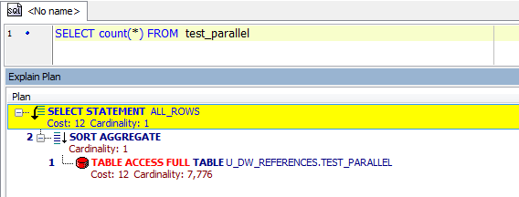

alter table test_parallel parallel 4

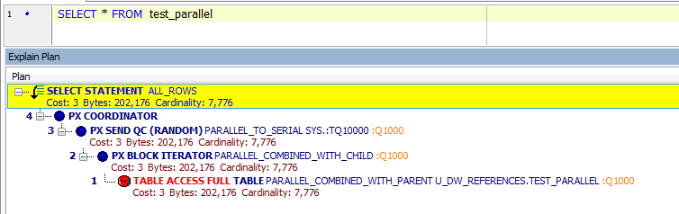

|  |  |
| --- | --- |
| No parallel | Cost 12, 37 msecs |
| Parallel | Cost 3, 41 msecs |

Parallel execution dramatically reduces response time for data-intensive operations on large databases. Simply expressed, parallelism is the idea of breaking down a task so that, instead of one process doing all of the work in a query, many processes do part of the work at the same time. The improvement in performance can be quite high.

## Task 02: CREATE Example of Parallel DML

CREATE TABLE test_parallel_dml AS

SELECT

LNG_ID ,

LNG_3C_CODE ,

LNG_2B_CODE ,

LNG_SCOPE_ID ,

LNG_TYPE_ID ,

LNG_DESC

FROM U_DW_REFERENCES.t_languages

update test_parallel_dml set LNG_SCOPE_ID = 0;

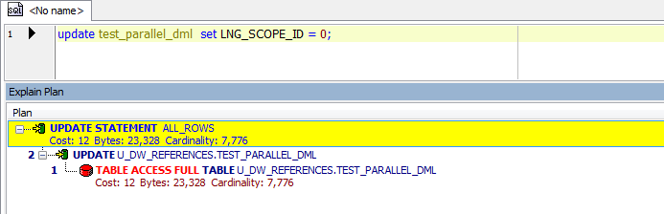

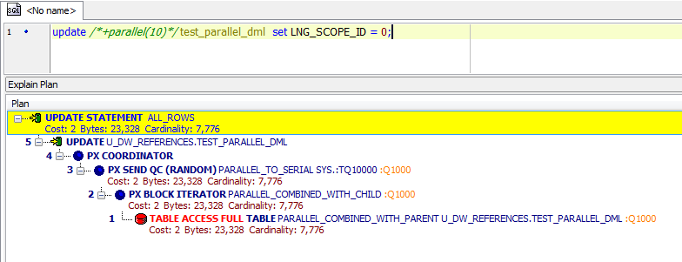

|  |  |
| --- | --- |
| No parallel | Cost 12, 61 msecs |
| Parallel | Cost 2, 67 msecs |

## Task 03: CREATE Example of Parallel DDL

CREATE TABLE test_parallel_ddl AS

SELECT

LNG_ID ,

LNG_3C_CODE ,

LNG_2B_CODE ,

LNG_SCOPE_ID ,

LNG_TYPE_ID ,

LNG_DESC

FROM U_DW_REFERENCES.t_languages;

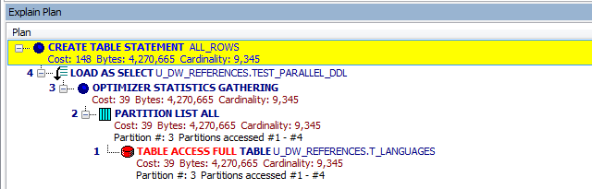

alter session force parallel ddl;

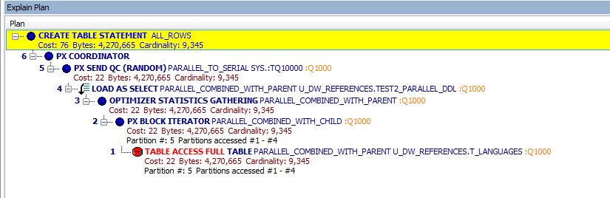

|  |  |
| --- | --- |
| No parallel | Cost 148, 122 msecs |
| Parallel | Cost 76, 104 msecs |

When you create a table or index using parallel DDL, two or more parallel slave processes work on behalf of your statement to create the object. Each parallel slave process creates a temporary segment during the creation process. At the end, the parallel coordinator trims each of these temporary segments to release any free space and then combines these segments into one segment.